Disclaimer:
Before you proceed, I attended Oxford University at the tender age of 14. This was a government-issued programme called Gifted and Talented. This group focused on individuals who progressed faster than those in classes. This was a turning point in my life as I was introduced to life at university, giving credibility to all my creative work.
I studied English literature creative writing and mathematics more formally in university with a course to test my understanding of the subject with that in mind. Now I am more than capable and inclined to educate others as I passed this unit in the Oxford visit.
What is a Poem
?
Traditionally, a poem is a piece of writing that expresses a writer’s feelings or the feelings of a persona. A poem was classified by the analysis of the language. This posed problems as individual classification varied from individual to individual.
What is
NOT
a Poem
?
A Prose
A Prose is not an example of a poem. A prose such as Willam Shakespeare’s Romeo and Juliet has certain characteristics of a poem. However, due to the nature of it facilitating the speech/ dialogue between Romeo and Juliet. It is not about an individual it is about two lovers. This prose feels like a poem with it intricate dance of rhythm and rhymes which will be discussed further. It is creative craft showing not telling of characters emotion love for each other.Techniques for Craft Nostalgic Poems:
Show ,
Don’t Tell
Showing Don’t Tell is a Framework for crafting beautiful story of any size. It is focused on the principle of giving a imagery that users feel in the story. I have created a new show don’t tell addition framework focused on story telling to be adapted for poems.
The problem is that traditional framework such as
AFOREST,PEDAL
,PEELIA Paragraphs are focused
objectively
to informal
rewriting
. As a creative writer it is important to remember to
implementation
CRISIS
,PIVOTS and EMOTION to craft nostalgic poem and engaging fiction
.
Poem still classed it is to research what type of poem works for you.
What should I explore?
Theme dicates the setting of the poem and 5W Who ,What ,When , Why ,Where is explored. How it is explored is for the writer to decide. You goal as a poet is to systemically ly paint a picture inot the mind of the reader given them an something nostalgic to remember.
Exploring abstract Concepts
Abstract Ideas are foundation to nostalgic poetry this is because
How to
show ,and
not tell?
C — Character
Your characters are the heart of the story. Readers must care about them, root for them, or even fear them. Focus on giving each character depth, quirks, and motivations that drive their actions.
Tip: Avoid flat characters. Even villains need a reason behind their actions.
R — Relationships
Stories are
fuelled
by relationships — whether they are between friends, enemies, or lovers. Conflict within relationships creates tension and emotional investment for readers.
Tip: Make sure the relationships evolve throughout the story, whether positively or negatively.
I — Internal Conflict
Every character should have inner turmoil. This conflict doesn’t just move the plot forward; it deepens the emotional stakes. Whether it’s fear, self-doubt, or moral dilemmas, internal conflict adds complexity.
Tip: Give your protagonist a personal struggle that parallels their external obstacles.
S — Stakes
What’s at risk? Stakes keep readers on the edge of their seats. Whether it’s physical danger, emotional loss, or a missed opportunity, stakes should be clear and significant.
Tip: Continually raise the stakes to increase tension as the story progresses.
I — Inciting Incident
This is the catalyst that sets the story in motion. It disrupts the character’s normal life and forces them into the main conflict of the story.
Tip: The inciting incident should happen early and create urgency in the narrative.
S — Setting
The setting is more than just a backdrop. It influences mood, affects characters’ decisions, and can even become a character itself. A well-crafted setting adds depth and texture to the story.
Tip: Use sensory details to immerse readers in the world of your story.
PIVOTS: Crafting Dynamic Story Arcs
The PIVOTS framework — Pacing, Imagery, Voice, Obstacles, Tension, and Subtext — helps guide the structure and flow of your narrative. This is where you control how the story unfolds, drawing readers in and holding their attention.
P — Pacing
Pacing dictates the speed at which your story moves. It should vary to maintain interest. Faster pacing is suited for action, while slower pacing allows for reflection and emotional development.
Tip: Alternate between fast and slow scenes to create a natural rhythm in your storytelling.
I — Imagery
Vivid descriptions help readers visualize scenes and experience emotions more deeply. Whether it’s a stormy night or the warmth of a hearth, imagery is crucial for building atmosphere.
Tip: Use metaphors and sensory details to create memorable visuals.
V — Voice
The voice is the unique tone and style of both your characters and the narrator. It must be distinct and consistent throughout the story, reflecting the personality and mood of your narrative.
Tip: Experiment with first-person, third-person, or omniscient narration to see what best fits your story.
O — Obstacles
Obstacles create conflict and propel the plot forward. Without obstacles, the story becomes stagnant. Every time a character solves one problem, another should arise.
Tip: Make the obstacles progressively harder, testing your character’s resolve.
T — Tension
Tension is the emotional charge that keeps readers engaged. Whether it’s a slow-burning sense of dread or a fast-paced chase, tension is key to maintaining interest.
Tip: Use cliffhangers and unresolved questions to build tension across scenes.
S — Subtext
Subtext is the underlying meaning that isn’t stated outright. It adds depth and complexity, especially in dialogue and character interactions. What’s left unsaid often speaks volumes.
Tip: Use subtext to create subtle tension or to reveal hidden aspects of a character’s motivation.
EMOTION: The Heart of Fiction
The EMOTION framework — Emotion, Motivation, Obstacles, Theme, Imagery, Observation, Narrative Voice — focuses on ensuring your story resonates emotionally with the reader. Readers should feel something when they engage with your fiction.
E — Emotion
Every scene should evoke some kind of emotion, whether it’s excitement, sadness, fear, or joy. The deeper the emotional connection, the more invested readers will become.
Tip: Tap into universal emotions like love, fear, or anger to ensure your story resonates broadly.
M — Motivation
Your characters’ actions must be driven by clear motivations. Why do they do what they do? Whether it’s love, revenge, or survival, motivation is key to understanding your characters.
Tip: Make motivations complex, especially for antagonists. Villains often believe they are justified.
O — Obstacles
Obstacles are not only physical but can also be emotional or psychological. The more obstacles your character overcomes, the more satisfying their journey becomes.
Tip: Use both internal and external obstacles to challenge your characters.
T — Theme
Theme is the underlying message or idea in your story. It ties everything together and adds depth to the plot.
Tip: Don’t be afraid to explore complex themes like sacrifice, redemption, or freedom
.
I — Imagery
As in PIVOTS, imagery helps bring your story to life. Strong visual elements create emotional responses in readers.
Tip: Use imagery that mirrors the emotions or themes of your story.
O — Observation
Observation helps you bring subtlety into your characters’ interactions and the world they inhabit. By showing small details, you allow readers to infer deeper meanings.
Tip: Trust your readers to pick up on clues without explaining everything.
N — Narrative Voice
Your narrative voice should align with the tone and mood of the story. Whether you’re telling a
sombre
tale or a humorous adventure, make sure the voice remains consistent.
Tip: Experiment with tone, sentence structure, and vocabulary to create a unique narrative voice.
How to create Perfect Rhythm and Rhymes?
To form a rhyme here is a an algorithm:
- create a phrase and count it syllabus
- create a second phrase with the number of syllabus
- Join the two in a sentence and it will form a rhyme.
- This is the formal definite of a rhyming.
Tip 1 to perfect: Chose you vocab with intent.
The tokens /words used give weight to the rhythm. Choosing the correct words make or break the poem . The context semantic meaning of the poem must align with a clear objective .This means to be easily understood with a clear an concise meaning.
How to add Rhythm?
Rhythm appears naturally when rhyme, how perfect try thyme give a music queue or beat making a poem more memorable nostalgic. Our focus here is to create a pattern in the read mind that gibes people our feelings we are trying to show
.Tip 2 to perfect:
Add rhythm when you have dictated the flow of vocabulary after the draft. Unlerss you are musication this is a post step. Some musician should consider add the music beat first.
Brianstorming – Brainstorming is the process of gathering ideas and analuss them for a requirement .The goal of brianstrmaing is to list as making coherent ideas forming a comprehensive set of ideas branhing or not to faciltiate the implementation of something/
What is narrative concept art?
Narrative Concept Art is the idea of creating a narrative for a concept invented by me to dictate the objective of 5W or what I am illustratin have drawn. This narrative gives the viewser the persepcitve of whether i have achived it.
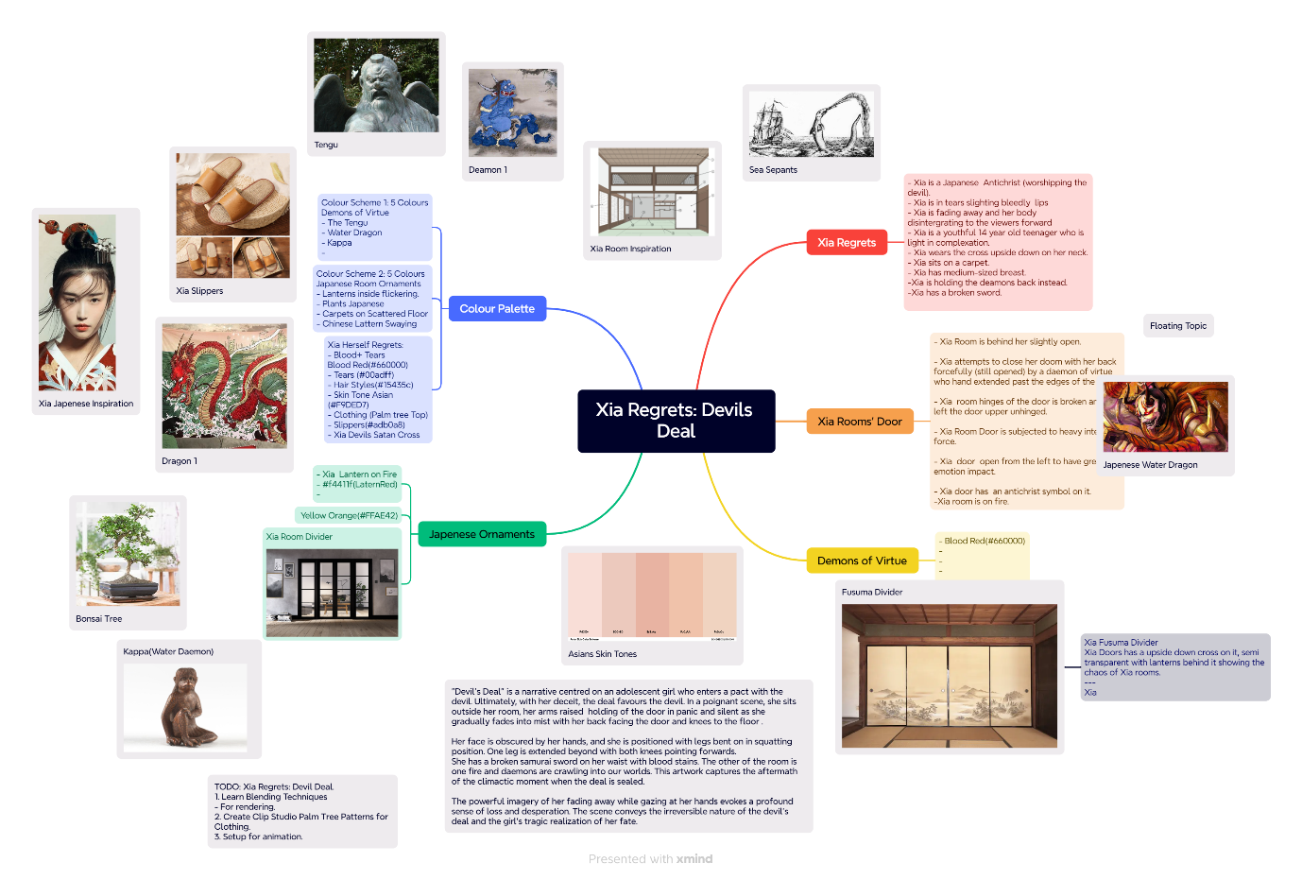
Xia Regrets - Deal Deal
Take for exmaple,Xia Regrets -Devil Deal.my painting in Clip Studio Paint Render of Xia a young person aged 16 with a lot for power a rich indidviual who want what see as real power. For this I have separated into a comic strip tradiotal used in Japan Called following a plot.She worshiped the deal to trick him. The devil in her deciet sent the v deamon of virtue to get her the devil favoured the devil. As a creative individual I have deceit to create a 4 set comic strip for xia regret described in the poem to show case the application This stripes 2 side pairs of animation subtle. Here is how it works conceptually, I have a haiku for the work to explore the power xia in first person want.
1.Introduction In the story we are introduced to Xia and devil worshipping room where she prayed for more power. He room is is filled with rich culture heritage from Japan's inspired with hidden devil worship element. In this draft , she is inform of a mirror devil type a shrine to protect her in communication in perspective.
To draw this i have chose a door showing a great room in front of a mirror . From standing to sitting legs crossed.
2. Development The about to pose is a drawing technique to posse correct a figure. The about shines as poses correctly are reflected in the author mind from drawing. She is posed a reflexion in the mirror pricked her finger to initialize ilaes the blood
- Twist
- The devil mirror image changes her reflection to a demons daemon bad evil entity whith scaly skin reaching out to the hear. lashing at her a shape shifter is born.
- Conclusion
She is attacked by the deamon of virtual and fire is started in room.
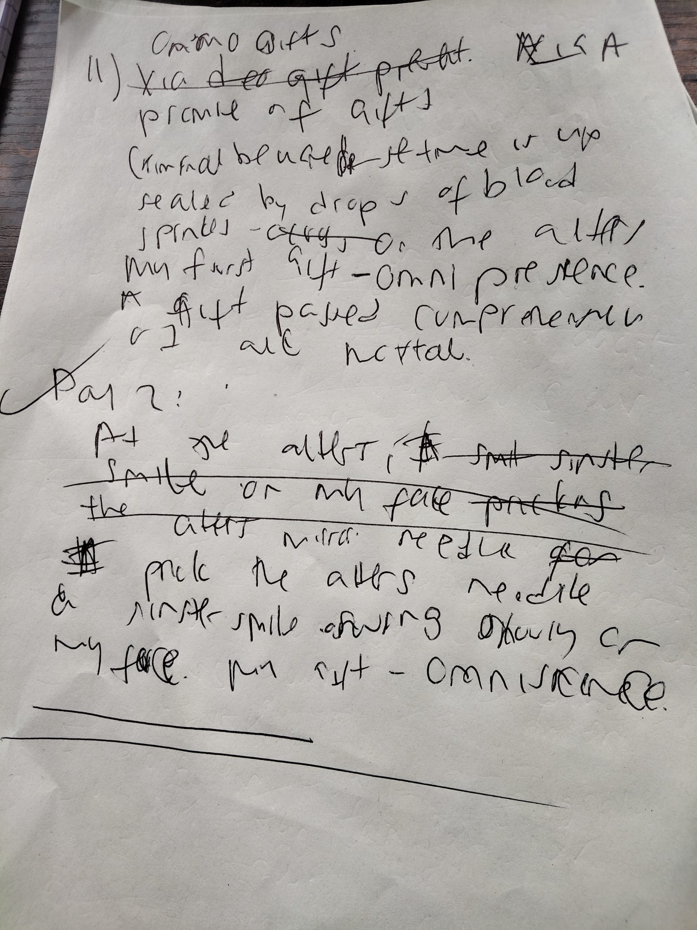
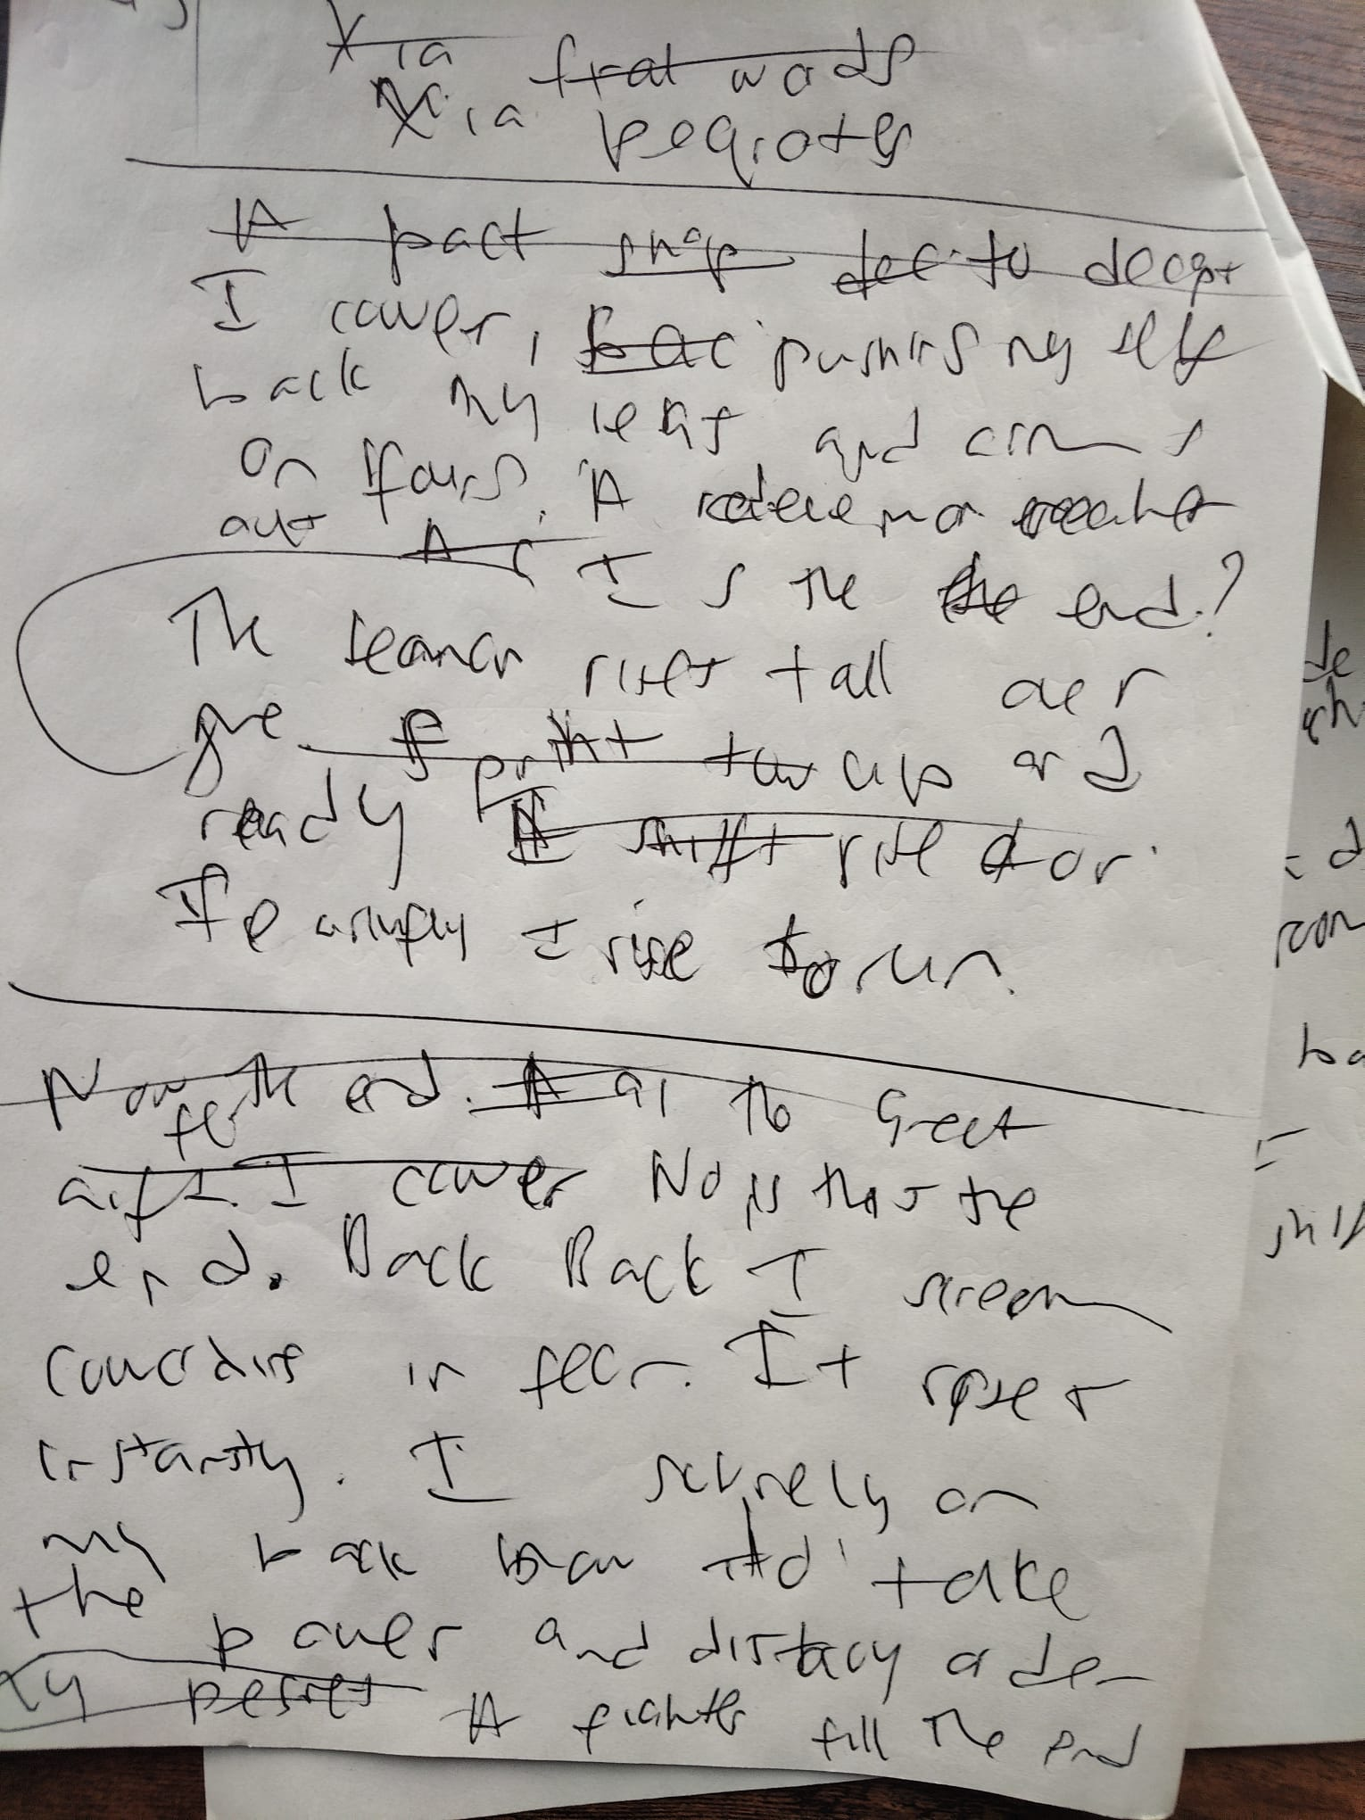
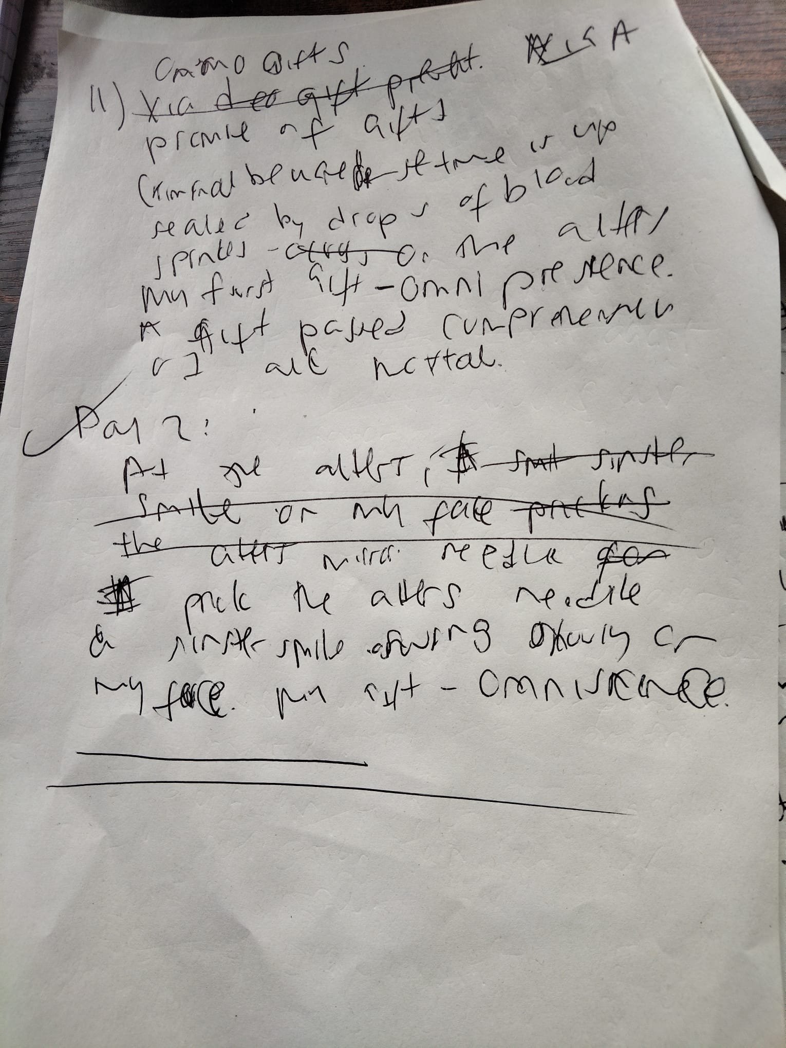
Konichiwa, I'm Xia Momochiyo. Rules are broken , powers is taken. Favouring us, A deceptive plot against a entity. – a daemon. To balance order, A paradigm shifts! From me to you, a royal call for justice. For all mortal, a balance in power. Join the cause for progress, a shift in balance.
— — With a sinister smile, 'Criss.` I cross my legs.' At the alters , Pop. I Prick my fingers bleed. A portal opens.
Whoosh! I receive my first gifts, A blessing beyond comprehension. Now sealed with drops of blood .stained by alter. Divide by realms ,A gift of my ingenious. Unrailed Omniscience, Two more to receive.
A change in the nature of knowledge. A paradigm shifts. — Dusk, now dawn. A sinister smile, wakes my face. 'Criss.` I sit crossed on my legs. ' at the alters . Pop. ,I Prick my fingers bleed, A portal opens. Thunder claps, Lighten strike. My laugh mutes the room. A blessing present it selfs . Now sealed with drops of blood .stained by alter. For now my gift, A paradigm shifts. A change in the nature of presence, Ungrieved Omnipresence – the power I now yield. One received, One more to receive. — With a sinister smile, wakes my face. 'Criss.` I sit crossed on my legs. ' at the alters . Pop. ,I Prick my fingers bleed, A portal opens.
I await my final gifts.
I exhale heavy, air escapes from within my lungs. Slowly, my reflection darkens like the night. reflection skin rotes like scaly sewage scorpion.
Looking on. I wait patiently for gift. smash, glass debris fly through. I gasp, the birth of a daemon of virtue .
Back on the floor, she rises above me. 'Back ,Back 'I scream! Hand stretched, Palm Curled. Screams echoes. The shape shifter yells, Now to take what is rightful mine. You life, my place. Your body, my choice.
— –
Online put your best work for other to see. A peom is art. An artist
https://www.nairaland.com/5508219/25-most-popular-igbo-masquerades
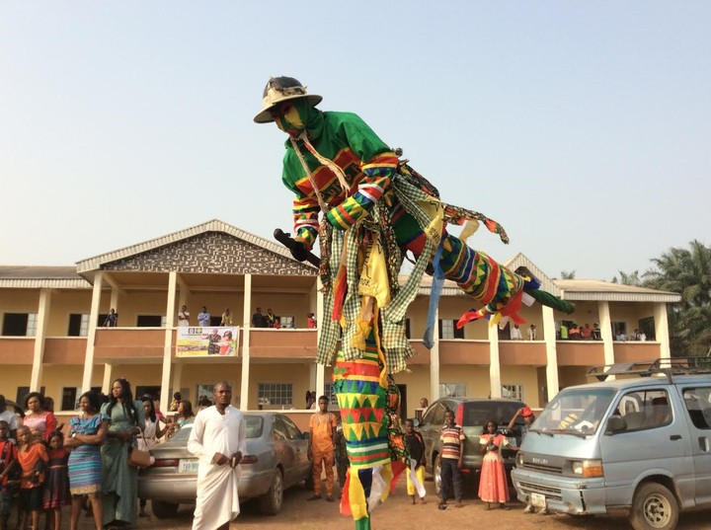

Tick, tap! The clock’s hand crawls towards midnight. Tock, tap! I tap my pen against the till, impatient in the crowd. A voice guides me, a soulless song further darkens the night.
- Memo- Speaking subconsciously about my autism and how it effects me
- Change this to reflect on the goal =write about autism later.
Tick, tap! Waiting for the last of the crowd to leave, I mutter, frustrated, sighing, disengaged.
Tick, tock! “Midnight, at last!” I cry with excitement. Grappling for my native attire, I race to catch the night’s final glimmer. Exiting, locking the shop with desperation.
Sunlight kisses my skin, waking my body. “Ya! Cha-Cha-Cha — Kwenu!” chant the people, waking my soul. “Ya! Cha-Cha-Cha — Kwezuonu!” I scream back. Tumbling, twisting, I transform into the majestic masquerade.
One with the chant, I dance, spinning with the wind’s intricacy. One with the people, children’s laughter ignites a fire in my soul, warmth in my heart. Twirling in a vibrant array of colours, I lift dust into the air. I am caught by every lens, preserving my spirit from every angle. Uplifted by curious children, I breathe new flames into their souls, Filling them with awe, breathing new life into their eyes.
“Whoa, Wow, Ahh!” they scream in excitement. Their joy fills the air, and they shower me with native gifts. Chased by their voices echoing in broad daylight — “GINI? BIA!”
Moving with grace and precision, I am admired, adorned, a living treasure of tradition. Never in spite, never lacking spirit — I am fuelled by culture, heritage, and time-honoured tradition. I am timeless, energized by our values. Adored by the crowd, celebrated by the children, I give life to culture. Always masquerading within the crowd, for what is young and yet to be, I became.
Now go, tell the tales that gave me life. Do not let our history fall and fade — forgotten, lost. Instead, cherish it, rejoice in it, and share it with open hearts. Now, GO! Pass it on, from one generation to the next. With the spirit of the Masquerade, we belong — together.

